An Ngoc Truong

truan004@mymail.unisa.edu.au

Paramedical emergency response system

INFS 1026

Table of Contents

Problem Statement 2

1. Stakeholders 2

2. Interview questionnaire 4

3. User stories 9

4. Formal requirements 11

4.1. Functional Requirements 11

4.2. Non-functional Requirements 12

4.3. Prioritisation method 13

5. Use case 13

6. Activity Diagram 15

6.1. Activity diagram 15

6.2. Activity diagram tool 16

References 16

Appendix 1 – Glossary 17

**System Requirements and User Experience SP2 2021 Assignment 1**  
**Requirements for a Paramedical Emergency Response System**

|  |  |  |
| --- | --- | --- |
| Version | Date | Notes |
| 1.0 | 01/04/2021 | Writing Problem Statement |
| 2.0 | 01/04/2021 | Identify Stakeholders |
| 3.0 | 02/04/2021 | Brainstorming of Interview Outline |
| 4.0 | 04/04/2021 | Create User Stories |
| 5.0 | 06/04/2021 | Identify Formal Requirements |
| 6.0 | 07/04/2021 | Use case Modelling |
| 7.0 | 08/07/2021 | Activity Diagram |

# Problem Statement

SA Ambulance Service requires the development for an ambulance emergency response system, which should meet basic requirements of an ambulance service that provide fast and immediate medical attention, and most appropriate response to requests for medical assistance. As a component of multiple terminal and computer across a wide range of network area, this system should cover various responsible for receiving Triple Zero calls, triaging and dispatching emergency cases, as well as storing data and providing information about policies and procedure to Paramedics. There should be a Mobile Data Terminal equipped for each Ambulance, which enables Ambulance Crew to use and receive informative data from the system.

# Stakeholders

There are stakeholders (actors) that involved in this system process and a set of categorised stakeholders will be mentioned in this part.

* 1. Stakeholders:
* Caller
* Patient
* Call Taker
* Dispatcher (EMDSO)
* Headquarter Dispatcher
* Ambulance Crew

Paramedics

Intensive Care Paramedics (ICP)

Extend Care Paramedics (ECP)

Rescue Paramedics

Ambulance Officers

Volunteer Ambulance Officer

* Team Leader of Paramedics
* Clinical Education Staff
* Emergency Operation Centre
* Fleet Manager
* Fleet and Medical Supply Staff
* Executive Management Team
* Chief Executive of SA Health
* IT Support
* Support Staff (finance, customer service, human resources, asset management and building services)

Customer Service Centre

Finance

Workforce Services

Other Support Staff

* 1. The following stakeholders have been identified:

|  |  |  |
| --- | --- | --- |
| Category | Degree | Stakeholder |
| Project stakeholder |  | * Headquarter Dispatcher * Fleet Manager * Fleet and Medical Supply Staff * Emergency Operation Centre * Executive Management Team * Chief Executive of SA Health * Customer Service Centre * Finance * Workforce Services * Other Support Staff |
| System stakeholder | First degree | * Call Taker * Dispatcher * Ambulance Crew (Paramedics) |
|  | Second degree | * Caller * Patient * Team Leader of Paramedics * Emergency Operation Centre * Finance |
|  | Third degree | * IT Support * Executive Management Team * Chief Executive of SA Health * Customer Service Centre * Clinical Education Staff |

# Interview questionnaire

There is a list of interview questionnaire which will generate an interview outline for an interview with the Call Taker.

Interview Outline

|  |  |
| --- | --- |
| Interviewee: Call Taker | Interviewer: |
| Location/Medium: Emergency Department | Appointment Date:  Startime:  Endtime: |
| Objectives:   * Current working process of Call Taker * Requirements of Paramedical Emergency Response System | Reminders: |
| Agenda:  Introduction  Background on Project  Overview of Interview  Topic to Be Covered  Permission to Record  Topic 1: Platform to run and use system  Topic 2: Method to receive and record calls  Topic 3: Create calls information form  Topic 4: Triaging support  Topic 5: First Aid support  Topic 6: After Triage  Summary of Major Points  Questions from Interviewee  Closing | Approximate Time: |
| General Observations: | |
| Unresolved Issues, Topics Not Covered: | |
| **Questions** | **Notes** |
| Question 1: Have you ever use an Ambulance Emergency Response System?   1. Yes, please move to question 2 2. No, please move to question 4   (closed-ended) | Answer:  Observations: |
| Question 2: Please tell me your experience about the previous system and rate your satisfaction from 1 to 5.  (open-ended) | Answer:  Observations: |
| Question 3: If you can change anything in that system, what features do you want to update?  (open-ended) | Answer:  Observations: |
| Question 4: How stress do you feel when working as a Call Taker?  (open-ended) | Answer:  Observations: |
| Question 5: Which kind of displaying interface that is considered to be the most user friendly one?   1. Display all the sections and information of all parts 2. Display the information classified by each part of the process   (closed-ended) | Answer:  Observations: |
| Question 6: As a Call Taker, which kinds of system platform that familiar for you to work with? (ranking from 1 to 5)   1. Website 2. Web app 3. Mobile app 4. Local host app   (closed-ended) | Answer:  Observations: |
| Question 7: Which is the more efficient and time-saving way to take calls among these given methods?   1. Take call via phone separately 2. Take call via system and record automatically 3. Take call via phone and get notifications from system   (closed-ended) | Answer:  Observations: |
| Question 8: As there are time limitations corresponding to triage categories, what do you think about having a timer set for each call?  (open-ended) | Answer:  Observations: |
| Question 9: Which one is the more effective method for a Call Taker to classified case’s triage category from primary triage?   1. Classify into emergency (Category 1 and 2) and non-emergency (others), then allocate in 5 categories 2. Directly allocate in 5 categories   (closed-ended) | Answer:  Observations: |
| Question 10: Which one is the most appropriate method for a Call Taker to display 5 categories of triage?   1. Number the categories from 1 to 5 2. Colour the categories (based on ATS) 3. Merge both number and colour   (closed-ended) | Answer:  Observations: |
| Question 11: Is it necessary to have detail descriptions of 5 triage categories to support identify difficult cases?   1. Yes 2. No   (closed-ended) | Answer:  Observations: |
| Question 12: Do you think it is necessary to have a collection of First Aid information to assist you during the call?   1. Yes, please move to question 10 2. No, please move to question 11   (closed-ended) | Answer:  Observations: |
| Question 13: Which one is the more efficient way to list essential and supportive information about First Aid?   1. Attach link from academic resources (online) 2. Summarize and store information in system   (offline)  (closed-ended) | Answer:  Observations: |
| Question 14: What information should system record about patient?  (a template of Patient Record)  (open-ended) | Answer:  Observations: |
| Question 15: How long do it usually take for recording patient information from an emergency call?  (open-ended) | Answer:  Observations: |
| Question 16: If the case is urgent and emergency (belong to Category 1 or Category 2), how long is it expected to be received by Dispatcher?  (open-ended) | Answer:  Observations: |
| Question 17: If the case is declared with non-emergency case (Category 3 to 5), should it display:   1. Two selections between Emergency Care Pathways and Alternative Care Pathway 2. Specific next step of progress identified for that case   (closed-ended) | Answer:  Observations: |
| Question 18: After triaging the calls, how will the system save cases information:   1. Save and update automatically during the call 2. Save automatically when finished triaging 3. Save manually when finished triaging   (closed-ended) | Answer:  Observations: |

# User stories

* Call Taker

1. As a Call Taker, I want to receive the calls within a short period of time (a few seconds) so that I can reduce the amount of time it takes to response to the cases.
2. As a Call Taker, I want to be able to access to collection of First Aid instructions so that I can be assisted faster in giving First Aid advices.
3. As a Call Taker, I want to be able to access information of 5 triage categories so that I can be assisted faster in triaging the cases.
4. As a Call Taker, I want to connect the calls with system to record the calls so that I can take necessary information about patient.
5. As a Call Taker, I want to have a template of information so that I can save up the time to fill in patient essential information.
6. As a Call Taker, I want to have a system to keep track on time of the calls recording so that I can manage the time limitations corresponding category cases.
7. As a Call Taker, I want to be able to send cases information to Dispatcher as soon as possible right after triage the cases so that we can manage to solve the cases on time.
8. As a Call Taker, I want to notify to the Dispatcher about the case so that they can keep track of the process.
9. As a Call Taker, I want to use the user-friendly system so that it can reduce my tiredness and stress.

* Dispatcher

1. As a Dispatcher, I want to notify to the Call Taker that I received the case so that they would keep track of the case.
2. As a Dispatcher, I want to receive cases within a short period of time (a few seconds) so that I can reduce the amount of time it takes to response to the cases
3. As a Dispatcher, I want to be able to access to list of AC availabilities so that I can assign received cases to.
4. As a Paramedics, I want to be able to access to the ambulance availabilities so that I can know which ambulance can be assigned.
5. As a Dispatcher, I want to be able to access to the recent location of AC so that I can assign received cases to the nearest available AC.
6. As a Dispatcher, I want to be able to use GPS and access patient recent locations so that I can assign received cases to the nearest available AC.
7. As a Dispatcher, I want to be able to contact AC so that I can check which AC can be available if no one is available by that moment.
8. As a Dispatcher, I want to be able to access the location of the nearest Headquarter so that I can assign received cases to the AC within that Headquarter’s area.
9. As a Dispatcher, I want to notify to the Paramedic about the case so that they can keep track of the process
10. As a Dispatcher, I want to be able to send cases information to Paramedic as soon as possible right after triage the cases so that we can manage to solve the cases on time.
11. As a Dispatcher, I want to use the user-friendly system so that it can reduce my tiredness and stress.

* Paramedics

1. As a Paramedic, I want to receive assigned cases within a short period of time (a few seconds) so that I can reduce the amount of time it takes to response to the cases.
2. As a Paramedic, I want to notify to the Dispatcher that I received the case so that they would keep track of the case.
3. As a Paramedic, I want to be assigned to work with other Paramedics so that we can form an AC.
4. As a Paramedic, I want to be able to access routing map so that I can signal when we are on road and keep track of the route to get to the destination.
5. As a Paramedic, I want to be able to use GPS so that I am able to access to the best route that leads to the patient current location.
6. As a Paramedic, I want to be able to receive information of patient from Dispatcher so that I can know the essential information of the case and notify that I received the case.
7. As a Paramedic, I want to be able to access to the availabilities and location of Hospital so that I can find the nearest Hospital to transport the Patient.
8. As a Paramedic, I want to be able to acknowledge the Hospital facility so that I can be informed with the issues in that Hospital.
9. As a Paramedic, I want to have a timetable shift so that I am able to access and aware of my shift.
10. As a Paramedic, I want to be able see the latest policies and procedures so that I can access and follow the news of necessary information.
11. As a Paramedic, I want to use the user-friendly system so that it can reduce my tiredness and stress.

# Formal requirements

This section describes the functional and non-functional requirements of the system.

## Functional Requirements

The functional requirements grouped by feature are:

**Response**

1. The system shall login and logout in the system.
2. The system shall allocate at least two available Paramedics to form an AC.
3. The system shall check the availability of Paramedic.
4. The system shall receive assigned cases from Dispatcher within 5 seconds.
5. The system shall notify the AC the location of the patient.
6. The system shall transfer information of Patient Record to Paramedics and give an indication of the type of case.
7. The system shall check the availability, location and facility condition of Hospital.
8. The system shall notify and update if there is any changes in the information of the case.
9. The system shall send AC information of available Hospital, its location, its facility condition and any other issues.
10. The system shall show the signal of the Paramedics when they are on the route to the case.
11. The system shall update and show the latest policies and procedures.
12. The system shall summarize the shift activities and the report including the recorded information of AC usage for Team Leader.
13. The system shall provide the Freedom of Information Act form for requesters.
14. The system shall display a report recording statistic of cases information from SAAS to SA Health.
15. The system shall turn on the lights and sirens if the case is Category 1.
16. The system shall response to any change or update actions within 3 seconds.
17. The system shall record the dates and times when key events happen.
18. The system shall display case on site to receive assessment from Paramedics.
19. The system shall find the best route for the AC to go to the patient location.
20. The system shall send notification about the case acceptance of AC to Dispatcher.
21. The system shall record the information of Paramedics working shifts.

## Non-functional Requirements

**Usability**

1. The system must display and sort the information classified by each part of the process.
2. The system must provide the user-friendly interface for Paramedics.
3. The system must contain both the online and buit-in help section to assist user ability.
4. The system must maintain the screen brightness to avoid dizziness and eyestrain while using in Ambulance vehicle.
5. The system must include alert sound effect with the button to change the volume for every notification.

**Reliability**

1. The system must encrypt all user data and cases’ information in system database.
2. The system must transfer information securely via local host database within the wide range of area.
3. The system must store and validate privileged password for Response process.

**Performance**

1. The system must response to every user actions within ten ms.
2. The system must support up to the maximum of 300 users without any performance degradation.
3. The system must follow this data format: mm/dd/yyyy.

**Supportability**

1. The system must upgrade and fix issues based on the feedback of user.
2. The system must be able to adapt with the new method of technology.
3. The system must update the lastest policies and procedures.

**Design Constraints**

1. The system must have capability to run on MDT.
2. The system must use PostgreSQL DBMS to manage and store data.
3. The system must use GPS to map and keep track of recent route.
4. The system must update inforamtion from SA Health website.

## Prioritisation method

The functional and non-functional requirements listed above were applied the *Value Cost Risk Matrix* and *Pairwise Comparison* tool corresponding to re-order by prioritisation from highest to lowest. The detail usage of the tool in this requirements’ arrangement will be demonstrated in the Appendix 1 section of this assignment.

# Use case

|  |  |
| --- | --- |
| Use case title: | Dispatch a case |
| Primary actor: | Dispatcher |
| Level: | Sea Level (Blue) |
| Stakeholders: | Dispatcher, Headquarter, Ambulance Crew |
| Precondition: | * The case was already received and triaged by Call Taker. * The triaged case was received by Dispatcher from the Call Taker. |
| Minimal guarantee: | Rollback of a changeable or uncomplete transaction |
| Success guarantee: | * Ambulance Crew is assigned with an appropriate case. * Ambulance Crew receives essential information of the case. * Headquarter receives the case from the nearest location. |
| Trigger: | Dispatcher accesses the system and has received the case. |
| Main success scenario:   1. Dispatcher views case information received from Call Taker. 2. Dispatcher accesses and checks the availability of AC. 3. Dispatcher defines the urgency of the case. 4. Dispatcher check the closeness of available AC recent location. 5. Dispatcher assigns and send case to appropriate AC and available Ambulance vehicle. 6. Headquarter receives assigned case from Dispatcher within the shortest distance. 7. Ambulance Crew receives and be assigned with dispatched case by Dispatcher. | |
| Extensions:  1a. Dispatcher can not view detail  1a.1 Report issues to IT Support  1a.2 Roll back. Dispatcher review case.  2a. AC is not available.  2a.1 Ask directly AC.  2b. The availability of AC is not updated to access yet.  2b.1 Roll back. Dispatcher access AC availability again.  4a. The recent location of AC is not updated to access yet.  4a.1 Roll back. Dispatcher access AC location again.  4b. Unable to identify caller’s current location.  4b.1 Roll back. Dispatcher access caller’s location.  4c. User has technical issues with GPS.  4c.1 Roll back. Dispatcher use GPS again. | |

# Activity Diagram

## Activity diagram

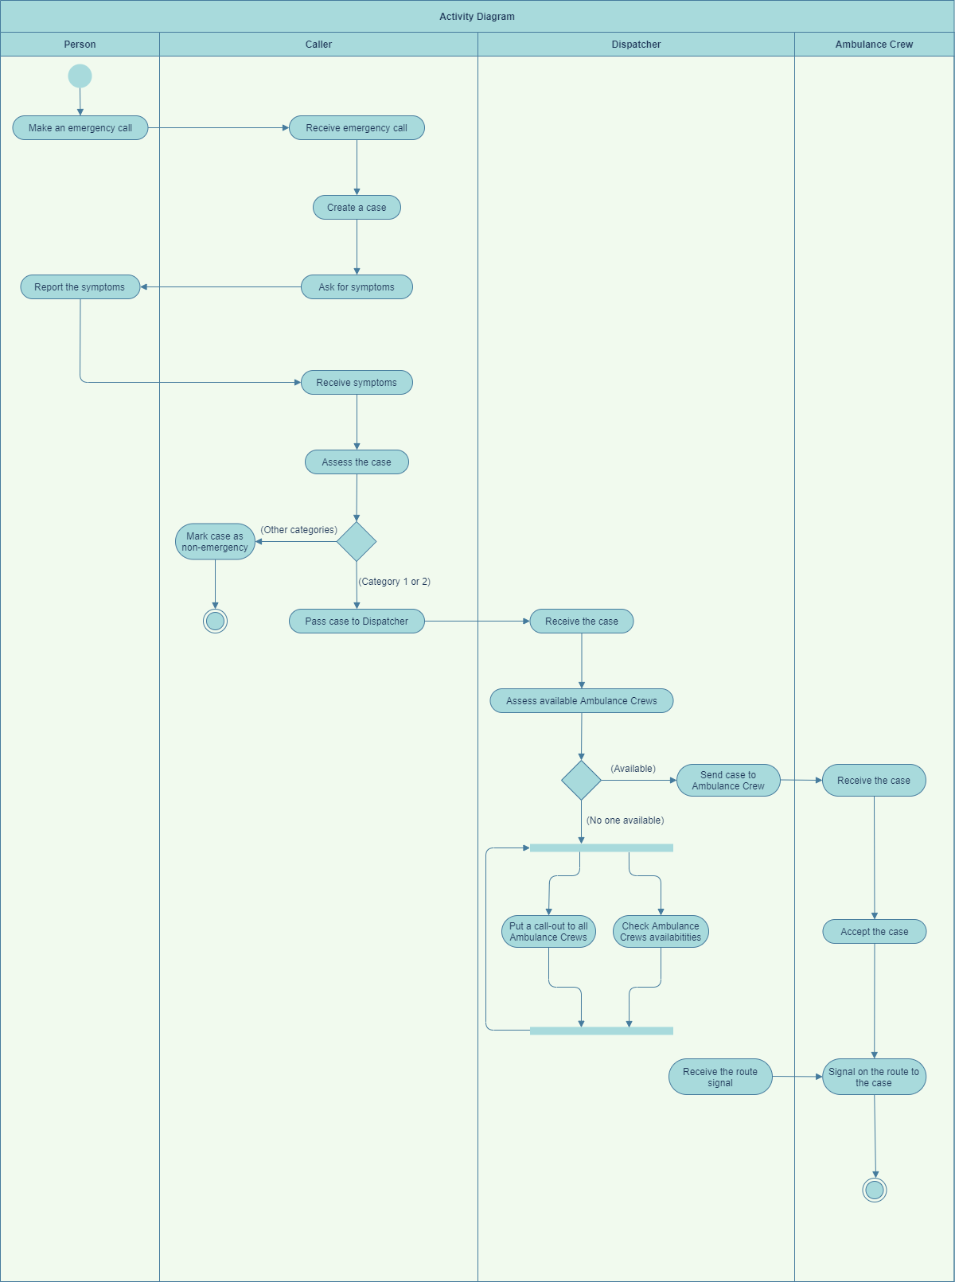

## Activity diagram tool

This activity diagram demonstrates the activity of 4 stakeholders named as Person, Call taker, Dispatcher and Ambulance Crew. There are swimlanes, branch and merge nodes, fork and join nodes, and UML appropriate notations be presented to illustrate the interaction among actors and the flow of process in this scenario. An online activity diagram tool that has used for this assignment is [*draw.io*](https://app.diagrams.net/)*,*  which is available for both online via website and offline via desktop app within usage of GitHub.

# References

* draw.io. *draw.io - Diagrams For Everyone, Everywhere*. [online] draw.io. Available at: <https://drawio-app.com/>.
* SA Ambulance Service. <<http://www.saambulance.com.au/> >
* SA Health Ambulance Service Dashboard <<https://www.sahealth.sa.gov.au/wps/wcm/connect/public+content/sa+health+internet/about+us/our+performance/our+hospital+dashboards/about+the+ambulance+service+dashboard/ambulance+service+dashboard> >
* Valacich, J. and George, J., 2016. *Modern Systems Analysis And Design, Global Edition*. Harlow, United Kingdom: Pearson Education Limited, pp.152, 226-229.

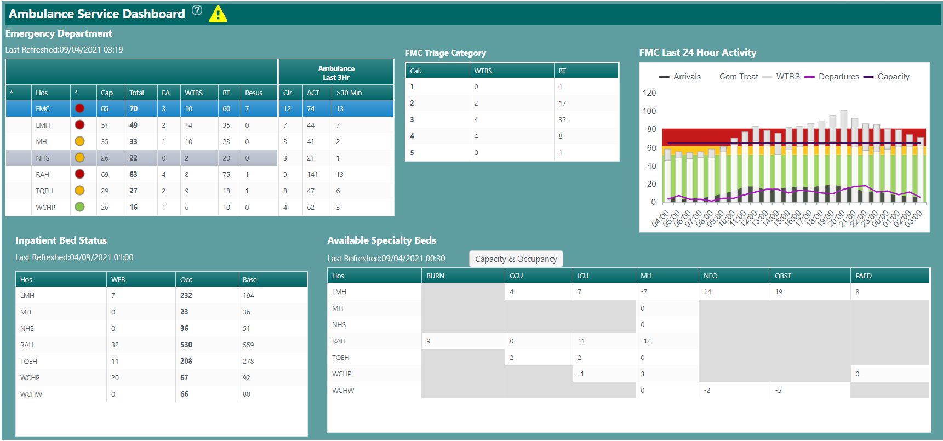

# Appendix 1

# Glossary

**Additional Information**

|  |  |  |  |  |  |  |  |  |  |  |  |  |  |
| --- | --- | --- | --- | --- | --- | --- | --- | --- | --- | --- | --- | --- | --- |
| Australasian Triage Scale | Only apply in Australasian (Australia and New Zealand)  Assign colour to categories of triage   |  |  | | --- | --- | | Australasian Triage Scale | | | Category 1 | Immediately | | Category 2 | 10 minutes | | Category 3 | 30 minutes | | Category 4 | 60 minutes | | Category 5 | 120 minutes | |

**Abbreviations**

SAAS: South Australia Ambulance Service

EOC: Emergency Operations Centre

EMDSO: Emergency Medical Dispatch Support Officer

AC: Ambulance Crew

ATS: Australasian Triage Scale

MDT: Mobile Data Terminal

**Other Functional Requirements**

***Handling the calls coming into 000***

1. The system shall automatically accept the incoming call.
2. The system shall hold the line during the Triaging process until one of the two sides hang off.
3. The system shall keep track of the amount of the time hanging on the call.
4. The system shall automatically record the call from the beginning of the incoming call.
5. The system shall save and store the recorded call in the Emergency Call Database.

***Triaging cases***

1. The system shall record the essential information of Patient including Patient name, Patient age, current location, Patient’s recent health condition and their triage category from the given template of Patient Record.
2. The system shall store the technical documents of First Aid.
3. The system shall store the technical documents of the five Triage Categories and display the ATS.
4. The system shall transfer the summary information of the cases to the next step of the process: emergency cases will be sent to Dispatcher and non-emergency cases will be sent to Alternative Care Pathway
5. The system shall send notification about the case to the Dispatcher.

***Dispatching***

1. The system shall transfer the summary information of the triaged cases from Triaging to Dispatching.
2. The system shall notify Call Taker about the cases acceptance of Dispatcher.
3. The system shall check the availabilities of AC.
4. The system shall check recent location of AC and find the nearest location to the Patient.
5. The system shall enable Dispatcher to call AC directly if there is no one available.

**Original Functional Requirements**

***Response***

1. The system shall receive assigned cases from Dispatcher within 5 seconds.
2. The system shall login and logout in the system.
3. The system shall allocate at least two available Paramedics to form an AC.
4. The system shall check the availability of Paramedic.
5. The system shall notify the AC the location of the patient.
6. The system shall send notification about the case acceptance of AC to Dispatcher.
7. The system shall find the best route for the AC to go to the patient location.
8. The system shall transfer information of Patient Record to Paramedics and give an indication of the type of case.
9. The system shall notify and update if there is any changes in the information of the case.
10. The system shall check the availability, location and facility condition of Hospital.
11. The system shall send AC information of available Hospital, its location, its facility condition and any other issues.
12. The system shall turn on the lights and sirens if the case is Category 1.
13. The system shall update and show the latest policies and procedures.
14. The system shall show the signal of the Paramedics when they are on the route to the case.
15. The system shall response to any change or update actions within 3 seconds.
16. The system shall record the dates and times when key events happen.
17. The system shall allow Patient to request for Freedom of Information Act.
18. The system shall display case on site to receive assessment from Paramedics.
19. The system shall record the information of Paramedics working shifts.
20. The system shall summarize the shift activities and the report including the recorded information of AC usage for Team Leader.
21. The system shall display a report recording statistic of cases information from SAAS to SA Health.

**VALUE COST RISK MATRIX**

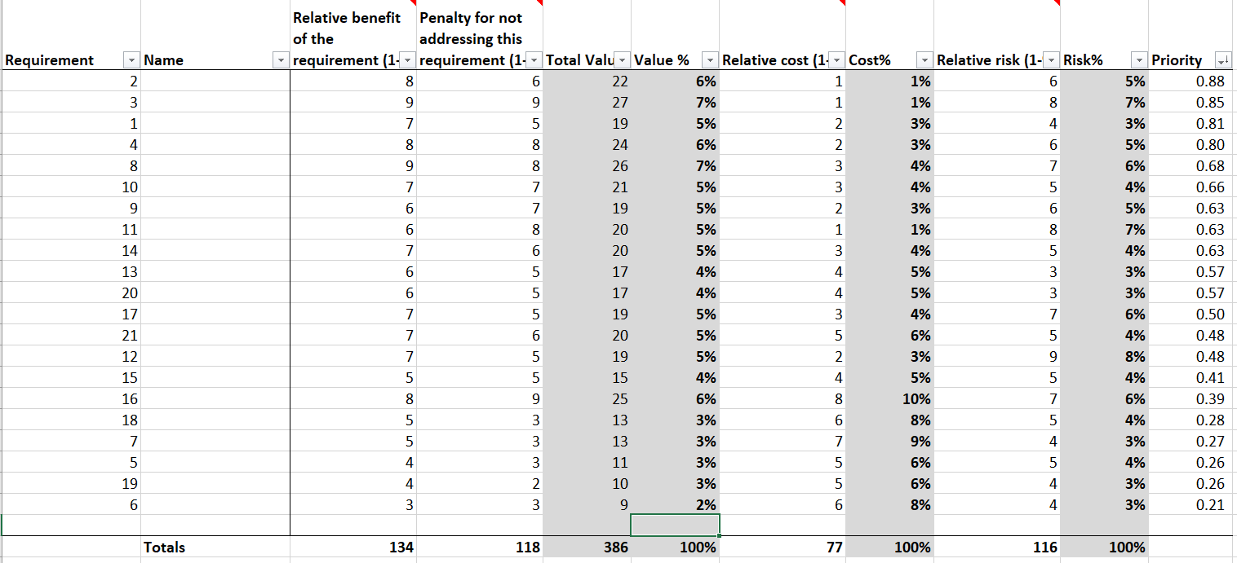

***Use Requirements Prioritisation Matrix***

**Non-functional Requirement Arrangement**

**PAIRWISE COMPARISION**

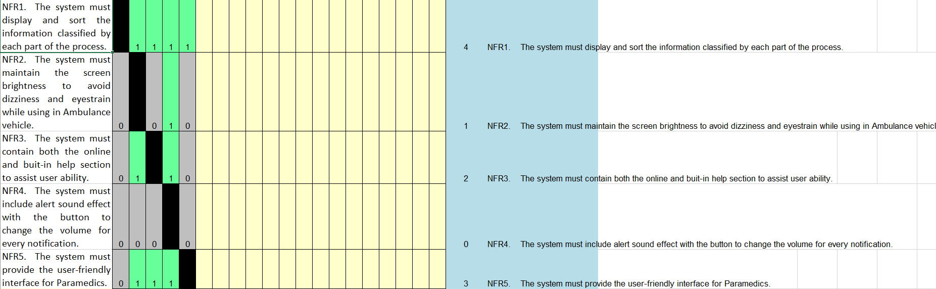

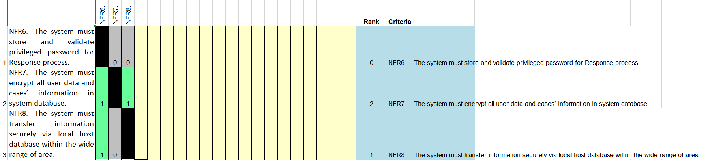

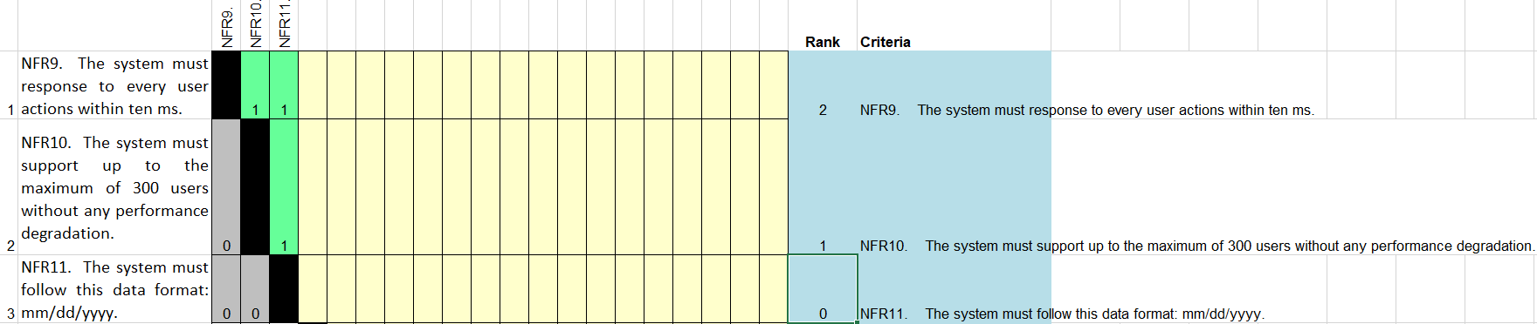

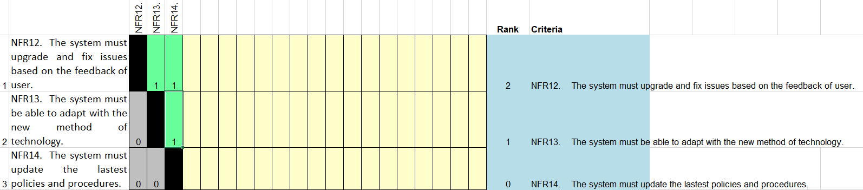

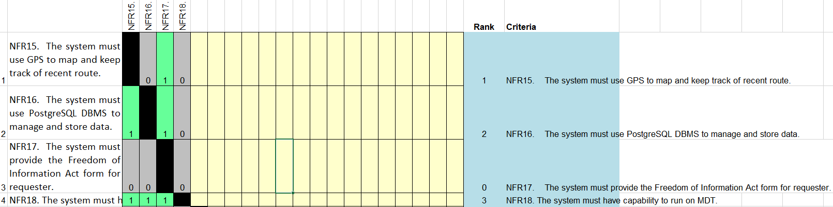

***Use Pairwise Comparison***